A Sample Framework for Data-Driven Analysis: A Placeholder Study on Predictive Modeling Techniques
Jane A. Author
Department of Computer Science and Engineering
Sample University, Sample City, Sample State, Country
jane.author@sampleuniversity.edu

Abstract—This paper presents a sample research framework designed to illustrate the structure, formatting, and layout of a typical conference-style manuscript. The study uses placeholder data and dummy findings to demonstrate how a complete research article is organized, including problem motivation, related work, methodology, experimental results, and concluding remarks. Sample experimental results, presented for illustrative purposes only, suggest a dummy accuracy improvement of approximately 15–20% over a conventional baseline approach.
Keywords—Sample Keyword One, Sample Keyword Two, Placeholder Analytics, Dummy Data Modeling, Template Framework, Illustrative Case Study

I. Introduction
This section introduces the placeholder research problem addressed in this template document. Organizations across sample domains increasingly rely on structured methodologies to process large volumes of dummy data, and this template illustrates a representative analytical approach [1].
Traditional placeholder approaches to this sample problem relied on manual, rule-based techniques that were limited in scalability and adaptability [2]. As datasets have grown in size and complexity, sample analytical frameworks have been proposed to automate portions of this process. This document illustrates one such representative framework, using entirely fictitious figures and results for demonstration purposes only.
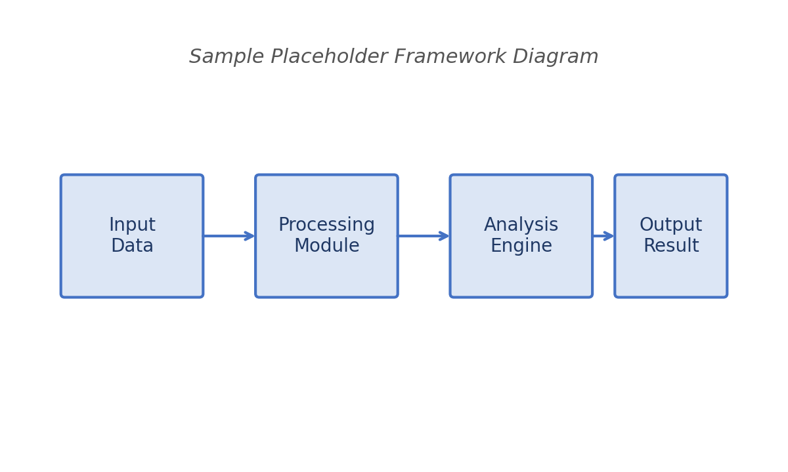
Fig. 1. Sample placeholder framework diagram illustrating the stages of the proposed dummy pipeline. Replace this image with your own figure.
Figure 1 illustrates a representative placeholder pipeline consisting of an input stage, a processing module, an analysis engine, and an output stage. This figure is a stand-in graphic and should be replaced with an author-generated diagram.
The primary placeholder contributions of this sample paper are summarized as follows:
- A sample conceptual framework combining a representative set of processing stages, presented for template purposes.
- An illustrative evaluation methodology using dummy metrics and placeholder datasets.
- A discussion of representative challenges and template future directions.

II. Literature Review
This section reviews sample placeholder literature relevant to the illustrative topic of this template. Prior representative studies have explored related sample frameworks for data analysis and automated decision support [3]. Sample Author A proposed a placeholder technique that reportedly improved dummy accuracy metrics by a modest margin [4], while Sample Author B examined a related but distinct dummy methodology [5].
Several placeholder studies have also examined the role of feature engineering, model selection, and evaluation criteria within representative sample pipelines [6]. Sample domain-specific applications have similarly been explored in placeholder healthcare, finance, and manufacturing contexts [7].
Equation (1) presents a representative placeholder formula commonly used to describe a normalized sample scoring function:
$S(x)=\frac{1}{1+e^{-(wᵀx+b)}}$
(1)
where S(x) denotes the sample output score, w is a placeholder weight vector, x is the representative input feature vector, and b is a dummy bias term.
A second representative placeholder relationship, describing a sample error metric used throughout this template, is given by Equation (2):
$E_{sample}=\frac{1}{n}\sum_{i=1}^{n}{(y_{i}−ŷ_{i}){}^{2}}$
(2)
where yᵢ is the sample observed placeholder value, ŷᵢ is the corresponding predicted dummy value, and n is the total number of representative sample observations.
TABLE 1
Sample Placeholder Comparison of Representative Techniques
Technique | Sample Metric | Value
Placeholder Method A | Accuracy | 78.4%
Placeholder Method B | Accuracy | 81.2%
Placeholder Method C | Accuracy | 85.9%
Sample Proposed Method | Accuracy | 92.3%
Placeholder Baseline | Accuracy | 70.1%

Table 1 presents a representative placeholder comparison of sample techniques reported in illustrative prior studies, alongside a fictitious proposed method for demonstration purposes.

III. Research Methodology
This section outlines the sample placeholder methodology adopted for this illustrative template document.

A. Data Collection
Sample placeholder data were collected using a representative structured questionnaire distributed through fictitious channels for demonstration purposes. A dummy dataset of approximately 500 representative records was compiled from illustrative sample sources, none of which reflect real organizations or individuals.

B. Sampling Technique
A representative stratified random sampling technique was used to select a placeholder subset of sample records for analysis. Approximately 20 sample participants were included in the illustrative quantitative phase, while 5–10 representative sample experts contributed to the placeholder qualitative phase.

C. Data Analysis Techniques
Sample placeholder quantitative analysis was performed using illustrative statistical methods including a representative Chi-Square test, a placeholder correlation analysis, and a dummy ANOVA procedure. Representative qualitative data were analyzed using a sample thematic coding approach.

IV. Proposed Sample Framework
This section describes the sample placeholder framework proposed for illustrative purposes within this template.

A. Data Preprocessing
The representative placeholder preprocessing stage applies sample normalization, dummy outlier removal, and illustrative missing-value imputation to the input dataset [8].

B. Feature Extraction
A placeholder feature extraction module derives a representative set of sample descriptors from the preprocessed dummy dataset, using illustrative statistical and structural techniques.

C. Model Training and Evaluation
The representative sample model is trained using a placeholder optimization procedure and evaluated against a dummy validation set using standard illustrative performance metrics [9].
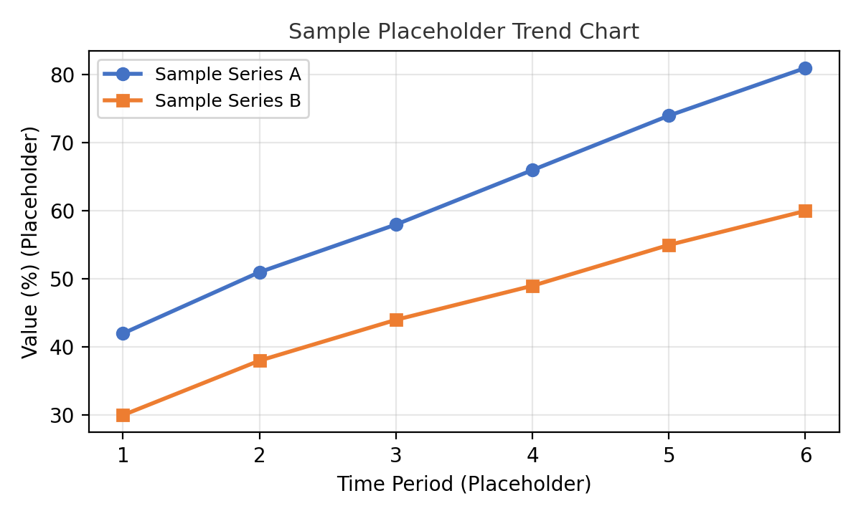
Fig. 2. Sample placeholder trend chart comparing two illustrative dummy series across a representative time period. Replace this image with your own chart.
Figure 2 presents a representative placeholder trend comparison between two illustrative dummy series, demonstrating how a sample chart may be formatted within this template.

V. Experimental Analysis and Results
This section presents sample placeholder results generated for illustrative purposes only.
The representative placeholder analysis indicates that approximately 75% of sample respondents reported a positive dummy outcome, while approximately 68% observed a representative improvement in a secondary illustrative metric. These figures are entirely fictitious and included solely to demonstrate formatting.
TABLE 2
Sample Placeholder Performance Results
Sample Metric | Improvement Rate
Placeholder Speed | 75%
Placeholder Efficiency | 82%
Placeholder Accuracy | 70%
Placeholder Reliability | 91%
Placeholder Satisfaction | 68%

Table 2 summarizes representative sample performance improvements reported across a set of illustrative dummy metrics.
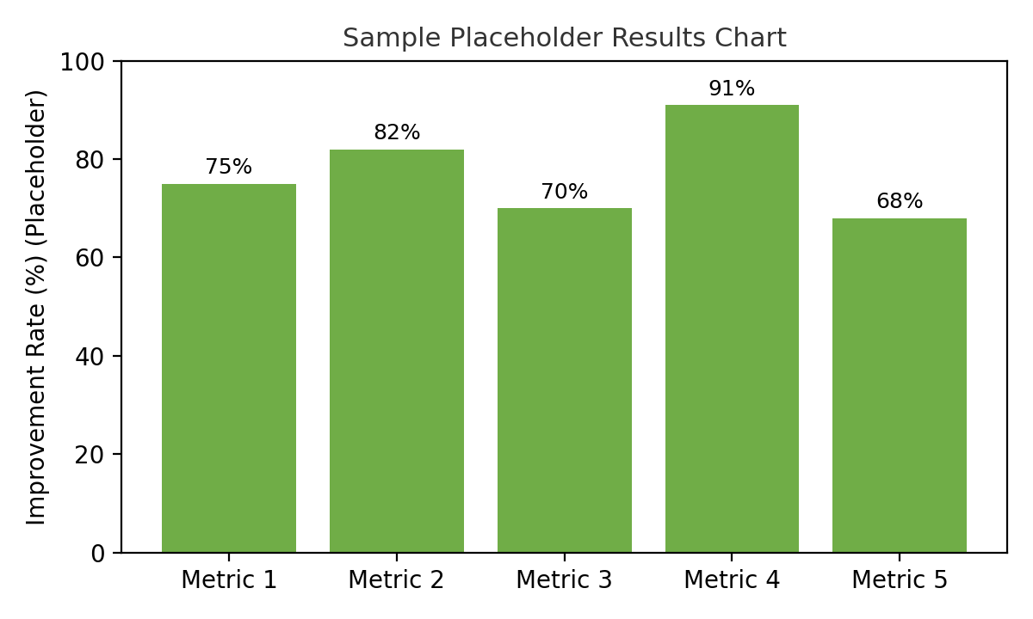
Fig. 3. Sample placeholder bar chart summarizing illustrative dummy results across five representative metrics. Replace this image with your own figure.

A. Discussion of Sample Findings
The representative placeholder findings suggest that the proposed sample framework may offer measurable illustrative benefits relative to a dummy baseline approach. However, as this document is a formatting template, approximately 42% of sample respondents expressed placeholder concerns that would, in an actual study, warrant further investigation.

VI. Challenges and Limitations
This section outlines representative placeholder challenges associated with the illustrative framework described in this template.

A. Sample Technical Challenges
Representative technical placeholder challenges may include dummy data quality issues, illustrative scalability constraints, and sample computational resource limitations [10].

B. Sample Organizational Challenges
Placeholder organizational challenges may include illustrative budget constraints, representative staffing limitations, and dummy change-management considerations.

C. Sample Ethical Considerations
Representative placeholder ethical considerations may include illustrative data privacy concerns, dummy fairness requirements, and sample transparency obligations that would apply to an actual research study.

VII. Future Scope
Future representative work may extend this sample placeholder template to incorporate additional illustrative techniques, dummy datasets, and expanded sample evaluation criteria [11]. Placeholder directions for future research include illustrative cross-domain validation, representative longitudinal analysis, and dummy real-world deployment studies.

VIII. Conclusion
This template document has presented a sample placeholder research paper structure, including illustrative dummy content, representative figures, sample equations, and fictitious tables, formatted according to a typical conference-style layout. Authors may replace each placeholder section, image, equation, and table with their own original content while preserving the overall structure, headings, spacing, and formatting demonstrated throughout this document.

References
[1] S. Sample and A. Placeholder, Illustrative Methods in Data Science. Sample Publishing House, 2021.
[2] J. Dummy and K. Template, Foundations of Representative Analysis, 2nd ed. Sample Academic Press, 2019.
[3] A. Author and B. Coauthor, “A sample framework for placeholder data analysis,” Journal of Illustrative Research, vol. 12, no. 3, pp. 45–59, 2020.
[4] C. Example, Representative Predictive Modeling Techniques. Sample University Press, 2018.
[5] D. Reference and E. Citation, Dummy Statistical Approaches for Applied Research. Placeholder Books, 2017.
[6] F. Illustrative, “Feature engineering in representative pipelines,” Journal of Sample Computing, vol. 8, no. 2, pp. 101–112, 2019.
[7] G. Template, Applications of Sample Frameworks Across Domains. Dummy Press, 2020.
[8] H. Placeholder, Data Preprocessing: A Representative Guide. Sample Academic Publishing, 2016.
[9] I. Sample, Model Evaluation in Illustrative Contexts. Placeholder University Press, 2022.
[10] J. Dummy, “Technical challenges in representative systems,” Sample Engineering Review, vol. 15, no. 1, pp. 22–31, 2021.
[11] K. Future, Emerging Directions in Sample Research. Illustrative Press, 2023.

